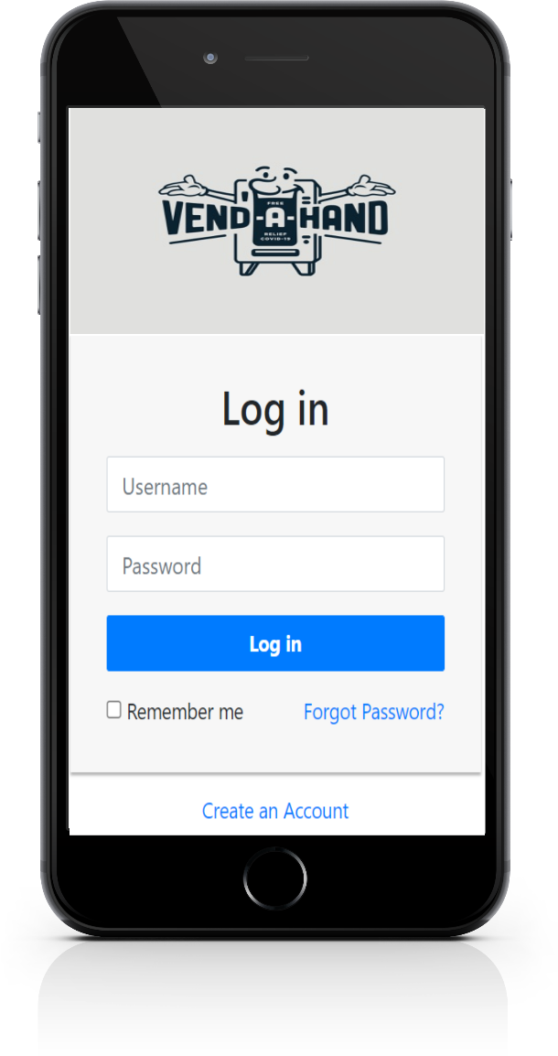**LOGIN PAGE**:-

user can proceed with this page if he has registered already. Or he/she should press a create a account (BUTTON) to create an account.

**CREATE AN ACCOUNT: -**

In this page helps to add a new user.

for this he/she has to provide his name, phone no, mail-id & so on.

**PICK (SELECT) AN ITEM: -**

This page usually lists existing items in vending machine and helps us to pick/select an items from list.

He/she can select multiple (of same item) & different items at a time.

**And there is options:**

**ADD TO CART:**

(helps to pick many items) or he/she can purchase a selected item at any time.

**BUY NOW:**

This button triggers to PAY PAGE of the selected item.

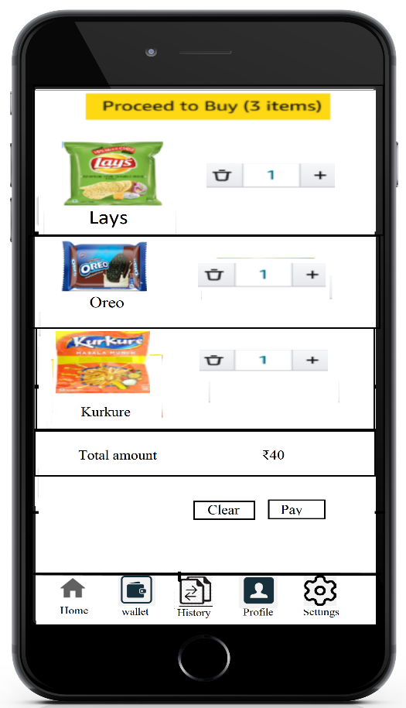

**CART PAGE:**

This cart page usually contains the selected item of the user

And he can modify the quantity or clear the cart according to his needs, at last he can proceed with his selected items and it gives an estimated amount and he can pay for selected items using pay button at bottom of the page.

**ALERT PAGE:-**

This just an alert page proceed to buy.

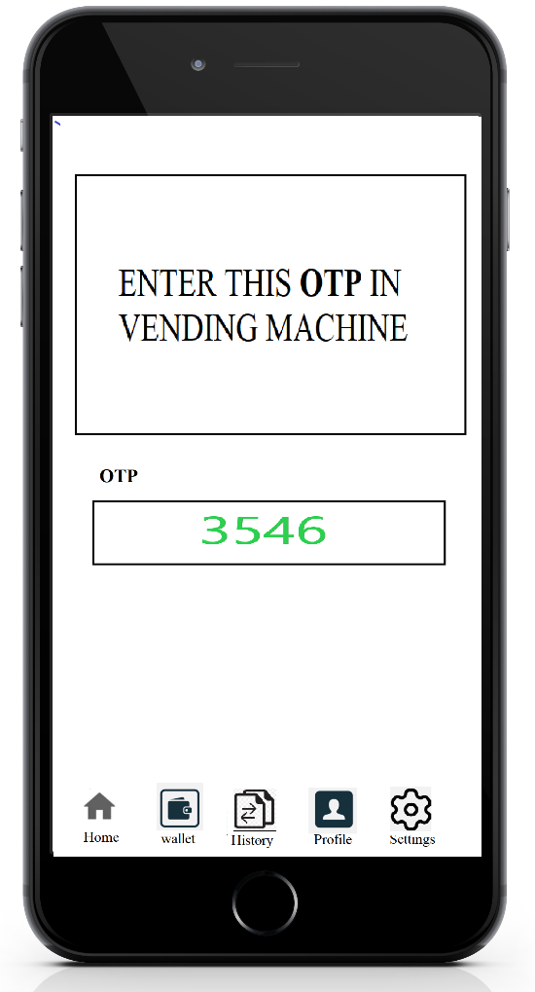**Auto gererated OTP..**

at last user will get an otp.

this otp play a key role for buying an item/items.

he/she has to enter the correct otp to buy the selected items in the vending machine...